CDGC – Configuration

User Guide

By

Mohamed Rasith M S

Table of Contents

IDGC User Roles 3

User Group 8

Users 9

# IDGC User Roles

1. A user can be created and assigned with out-of-the-box user roles. However, it is recommended to review the predefined user roles, identify the custom user roles concerning the business needs, and assign them when creating users.
2. You will create two custom user roles data steward and data owner. The data steward role is mainly responsible for managing assets in the CDGC application, such as creating and updating glossaries, systems, datasets, AI models, etc. The data owner role has view-only privileges to the assets but will participate in the change approval processes.
3. 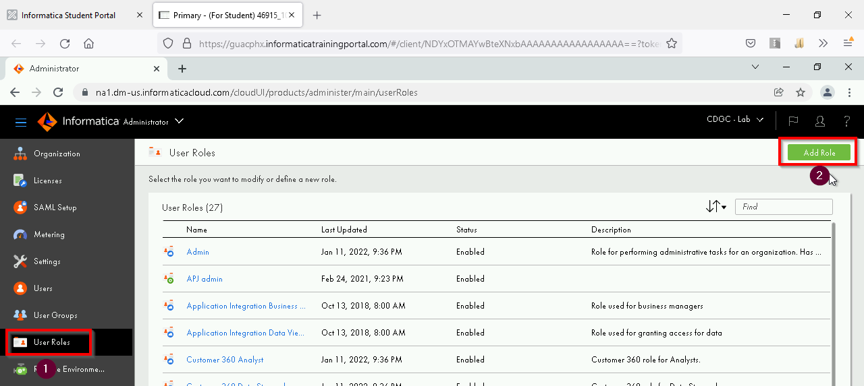Click the User Role menu from the navigation bar on the left, and then click the Add Role button.
4. Provide a role name in this format: ‘governance data owner’. Select ‘Metadata Command Center’ from the Service drop-down list and select the required privileges for different Asset Types under the Assets tab. Please refer to the subsequent steps for detailed privileges of Metadata Command Center and Data Governance and Catalog services. Once that is done, click the Save button for this custom user role.

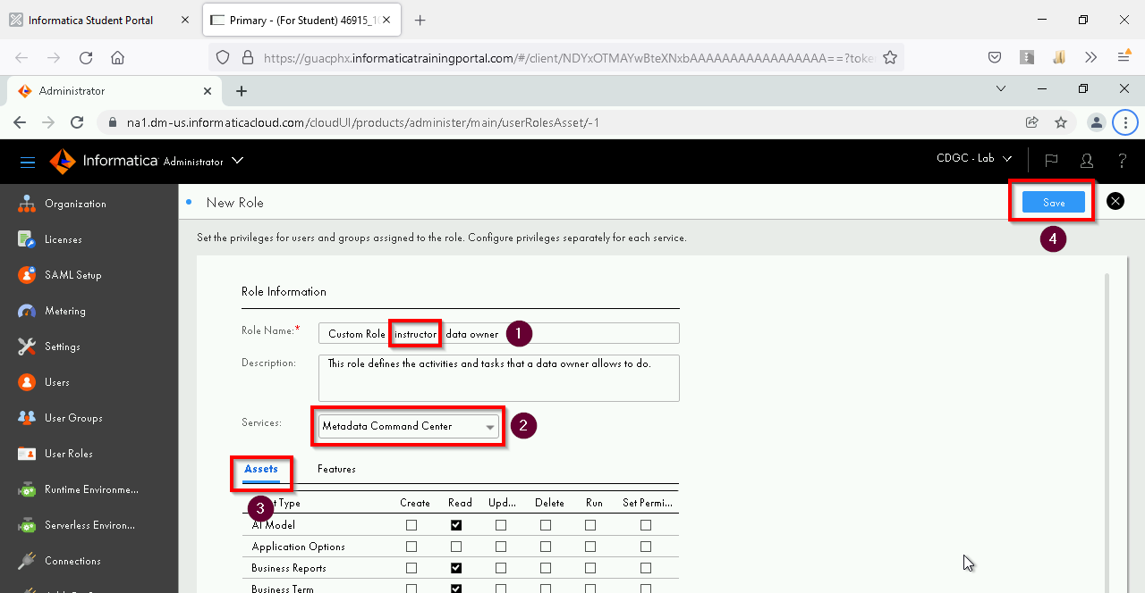

1. 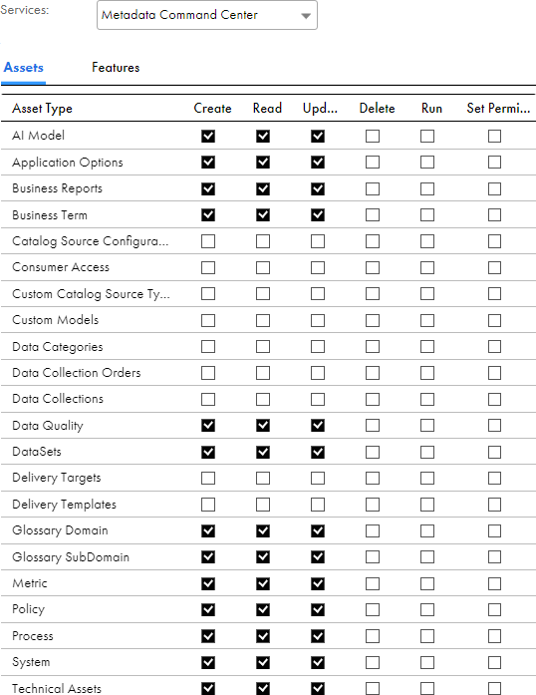For the Data Owner role, here is the list of privileges selected for different Asset Types under the Assets tab of the Metadata Command Center service:
2. For the Data Owner role, no feature will be selected for Features under the Metadata Command Center service:

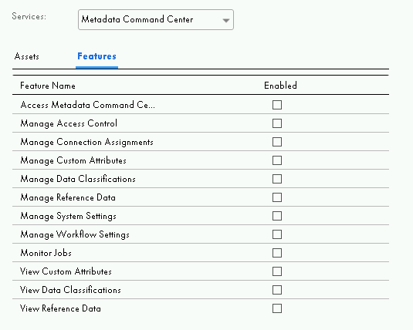

1. 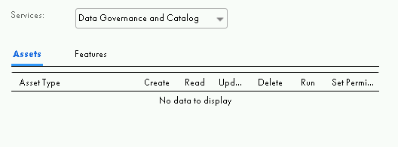No asset is available for Assets under the Data Governance and Catalog service:
2. For the Data Owner role, here is the list of privileges selected for Features under the Data Governance and Catalog service:

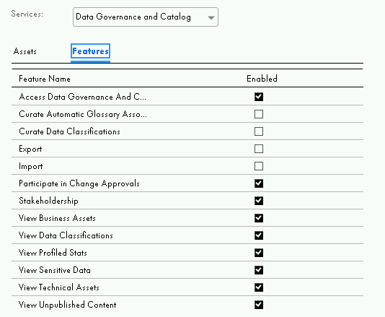

1. Now you can save the custom user role for the data owner.
2. Create another custom user role for the data steward. Follow the same steps as above:

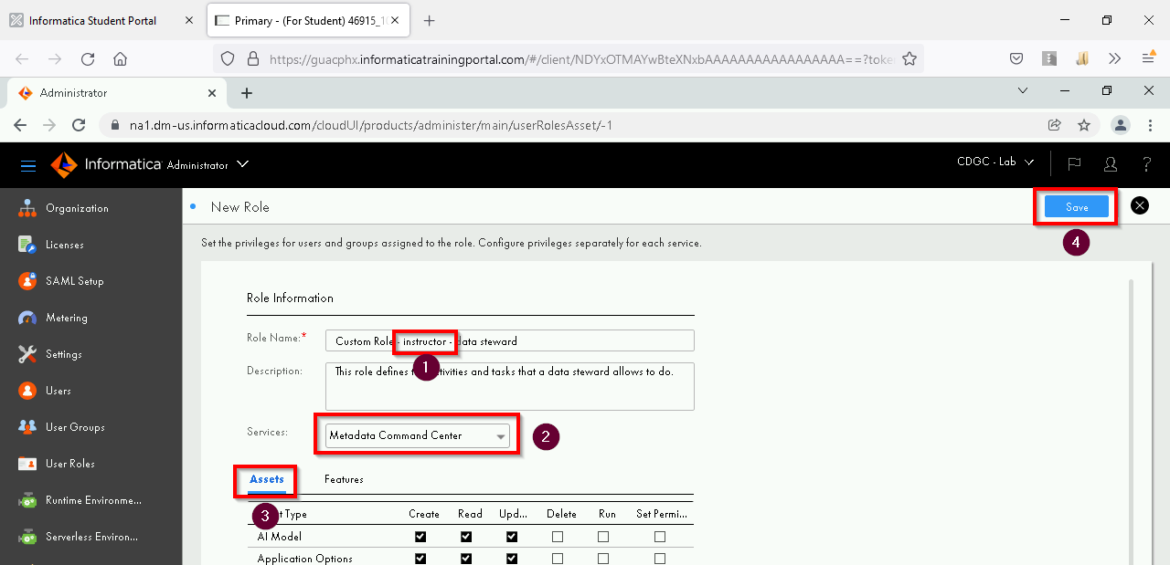

1. Here is the list of privileges to be selected for different Asset Types under the Assets tab of the Metadata Command Center service:

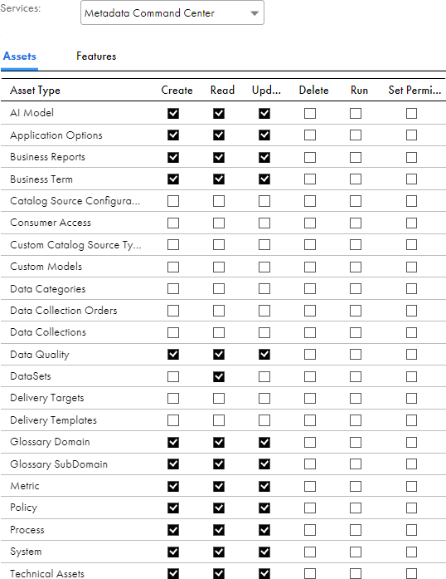

1. No feature will be selected for Features under the Metadata Command Center service:

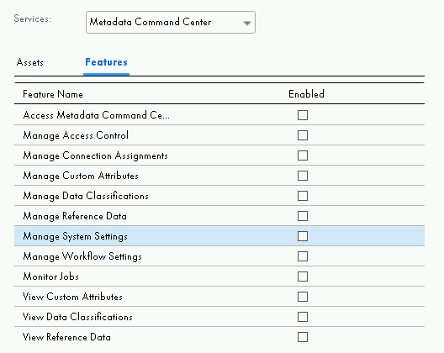

1. 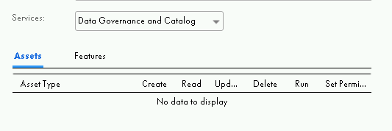No asset is available for Assets under the Data Governance and Catalog service:
2. Here is the list of privileges selected for Features under the Data Governance and Catalog service:

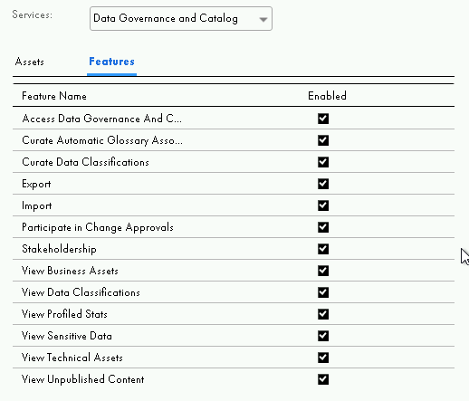

1. Here is the list of privileges selected for Features under the Human Tasks service:

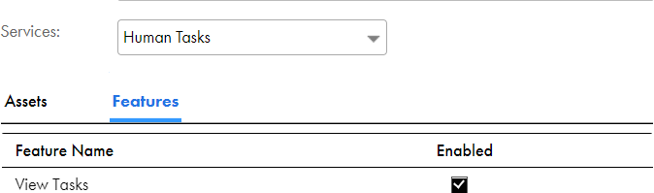

**Now you can save the custom user role for the data steward.**

# User Group

Instead of Assign created custom role to user, Create new user Group for each users.

Steps:

1. Go to Administrator -> User Groups -> New

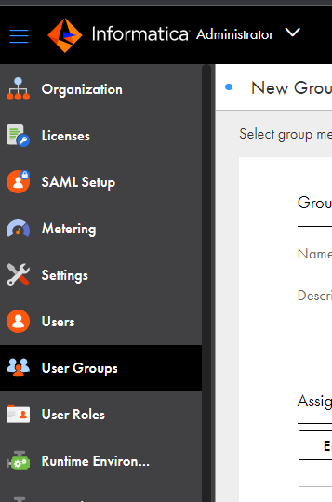

1. Enter appropriate group name and description.

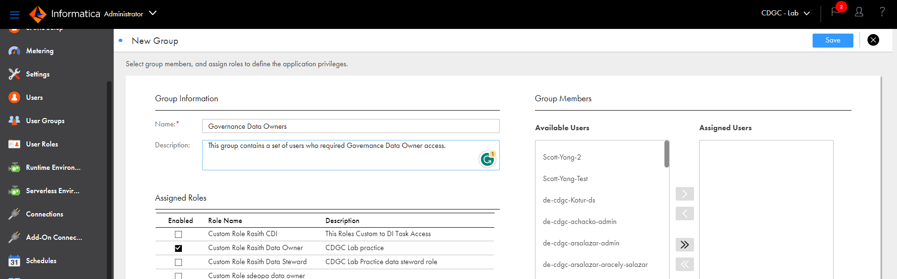

1. Select Customized User Role. Eg: Governance Data Owner.
2. If we already created list of user add the users.

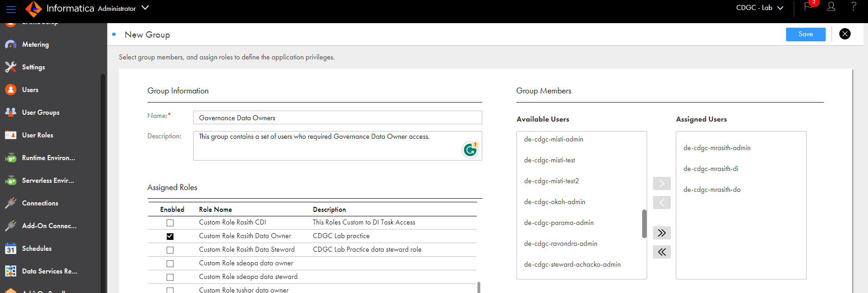

**Note: Please do the same steps for Data Steward**

# Users

Here we will see how to create user and add them to Group in detail.

Steps:

1. Go to Administrator -> User -> New

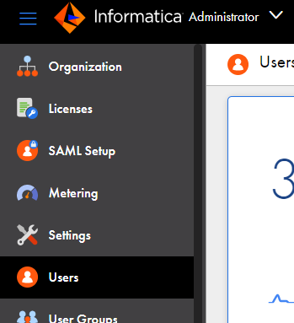

1. Provide the user’s first name, last name, job title, phone number and email.
2. Set authentication to native.
3. User name should be unique for each user.
4. Select the group as Governance data owners.

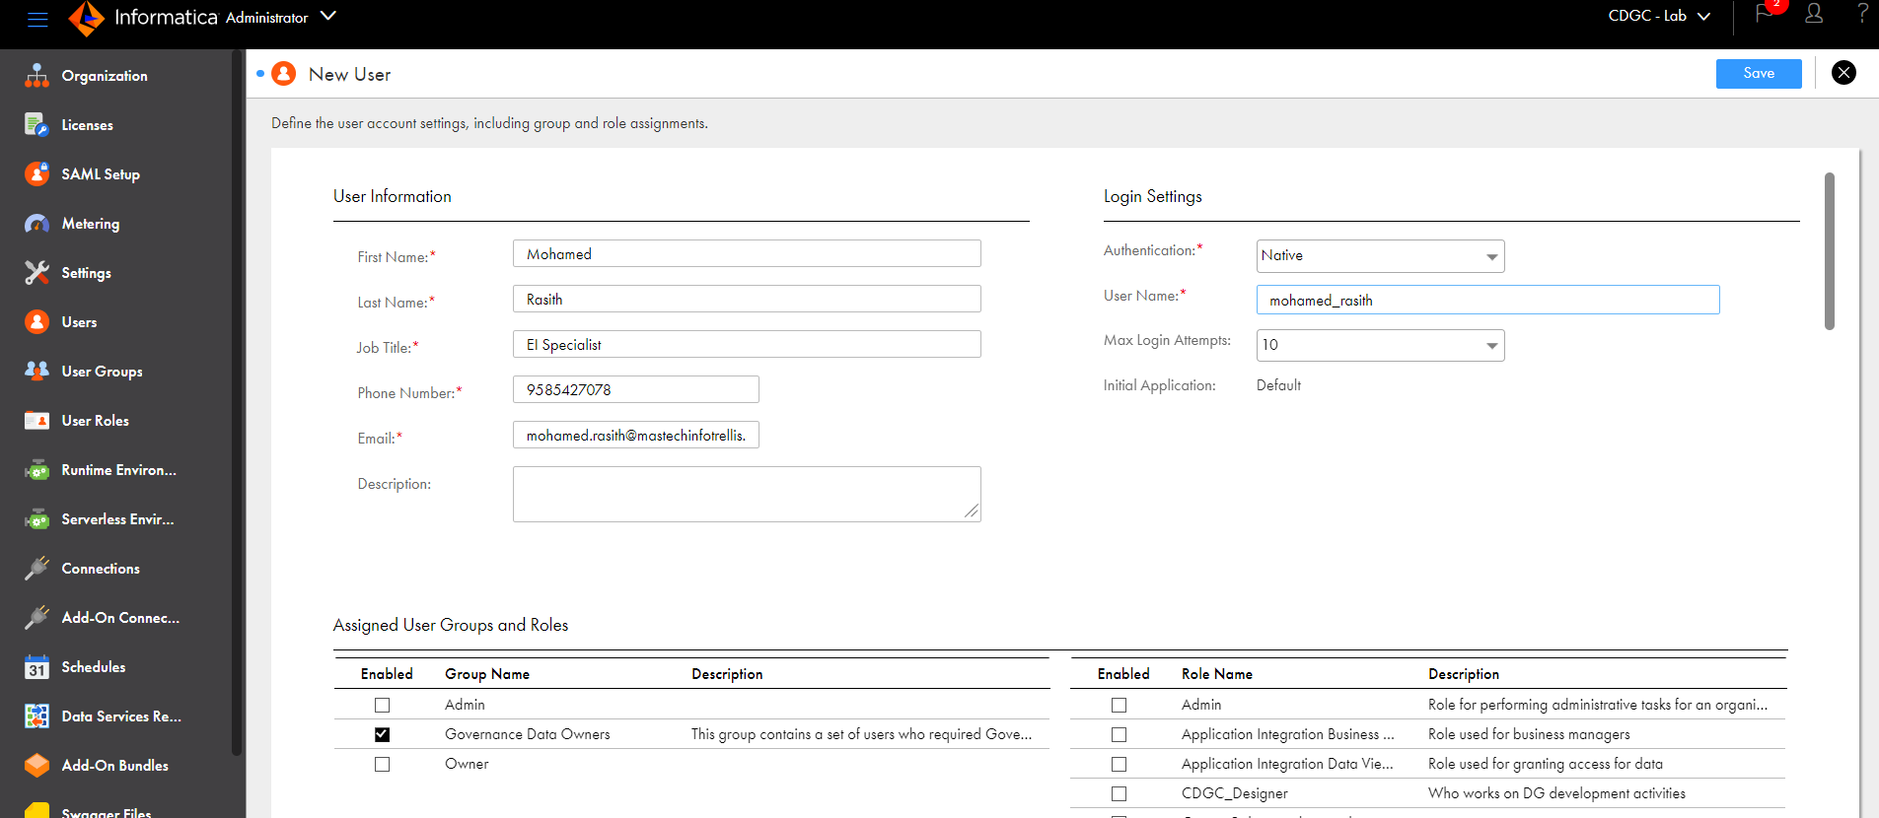

1. Save the user. Now the user is good to use as data owner.

**Note: Please repeat the same steps for Data Steward Users.**